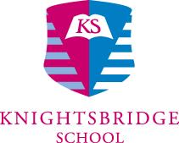

Head of Computing
Required for September 2024

Knightsbridge School currently educates 400 students from ages 3 – 16. The school, which is set in the heart of London, combines a warm and nurturing environment with excellent resources, a commitment to teamwork and the professional development of staff.

We are looking for a forward thinking, innovative and enthusiastic Head of Computing to join our team. In this role you will lead the development of the computing curriculum, teaching the subject up to GCSE. You will guide colleagues in the development of their own digital literacy skills to ensure the integration of technology into the school curriculum.

For an application pack and further details please see the school website site or contact Rosie Hill at r.hill@knightsbridgeschool.com or 020 7590 9000.

Closing date for applications: Friday 26th April (but please don’t wait until the deadline!)

Knightsbridge School is committed to safeguarding children and promoting the welfare of children and expects all staff and volunteers to share this commitment. We will ensure that all our recruitment and selection practices reflect this commitment. All successful candidates will be subject to Disclosure & Barring Service and other relevant employment checks.

